# RSI Indicator - Understanding and Correction

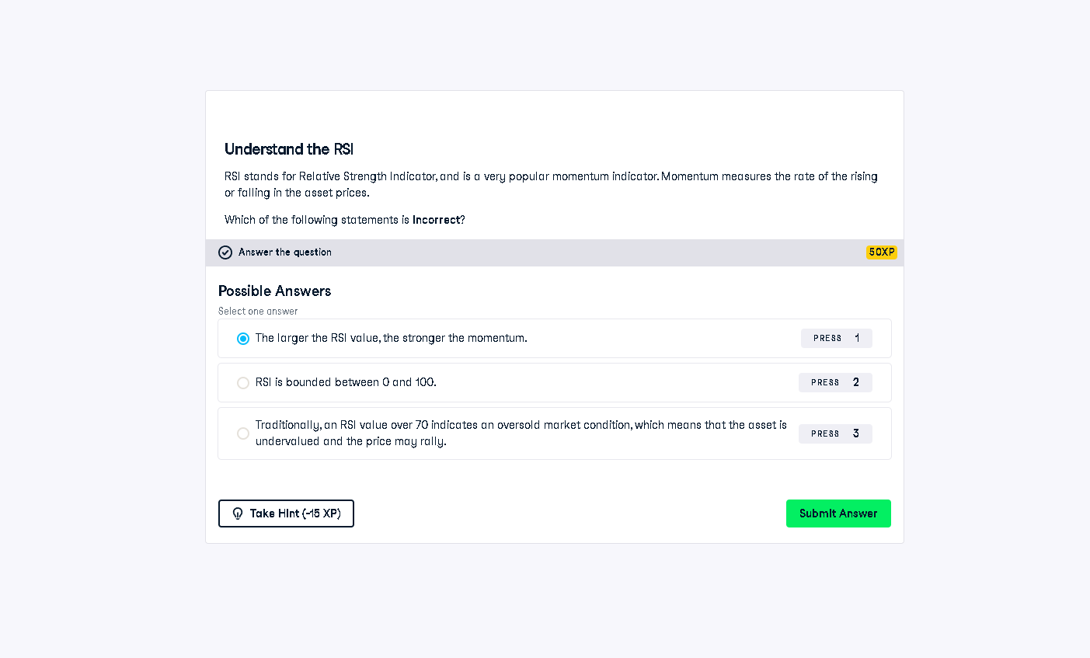

## Full Answer

Question:  
Which of the following statements is incorrect?  
  
Selected Answer:  
✔️ The larger the RSI value, the stronger the momentum.  
  
Correct Answer:  
✅ This is the incorrect statement. RSI does not directly measure momentum strength like ADX.  
Instead, RSI measures overbought (typically RSI > 70) or oversold (RSI < 30) conditions.  
It is not true that a larger RSI always means stronger momentum.  
  
Correct Statements:  
- RSI is bounded between 0 and 100.  
- RSI > 70 indicates overbought; RSI < 30 indicates oversold.

## Simple Explanation (50 Words)

The RSI doesn’t measure how strong momentum is; it measures if a stock is overbought or oversold. A high RSI doesn’t always mean strong momentum, just potential overbuying. So saying 'higher RSI equals stronger momentum' is wrong — that’s why it’s the incorrect statement in this question.